States
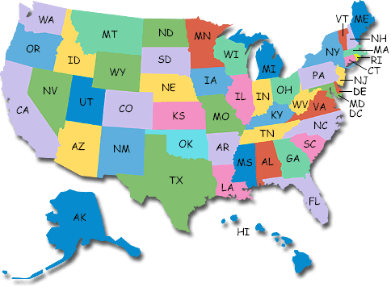
Introduction
Your project is to create a brochure on a state in the United States. Your teacher or you will choose a state.
Process
Download the brochure and save in your flashdrive or in your documents. Use the links to find your information. You can also find your own links. Following the directions on the brochure and you will have no trouble. When you are finished, drop to your teacher’s Dropbox folder.

