Make a 3 D Power Point
1. Make square/rectangle in the middle of the slide

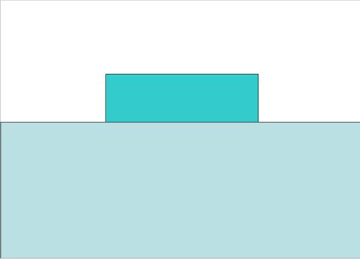
2. Create a rectangle that is 1/2 of slide.

3. Send the larger rectangle to the back and change the
color. This is your floor.

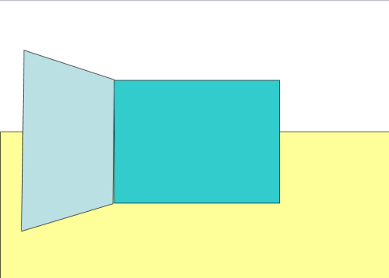
4.Add side wall. Shape = trapezoid
5.Put it on the slide then rotate.
Use the Picture menu circle arrow to rotate.

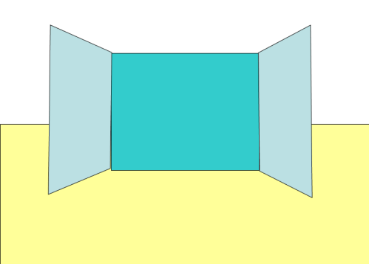
6.Copy and paste a second wall. Then rotate it into
place.

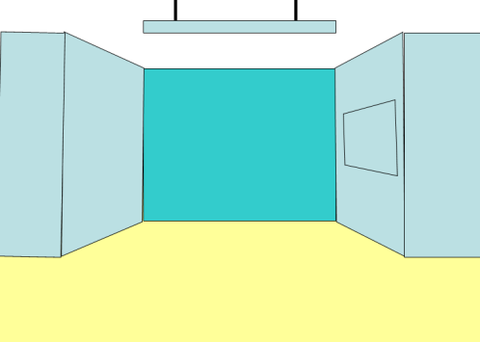
7. Add wall edge and a sign at the top.

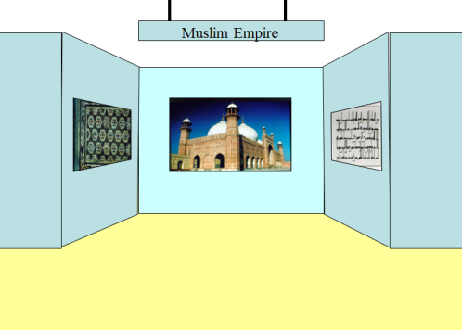
8. Add pictures and a sign title.

