Habitats
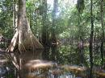
Introduction
Follow the directions for each task. You can find the worksheets on the assignment page.
Task
1. Make a folder and put your name on it.
2. Match the pictures of habitats to the name. Put the pictures in the box. Use Worksheet 1
3. Type the name of the habitat in the box under the animal. Use Worksheet 2
Conclusion
When you are finished, Ms. Beth will help you drop it.

