Day of the Dead
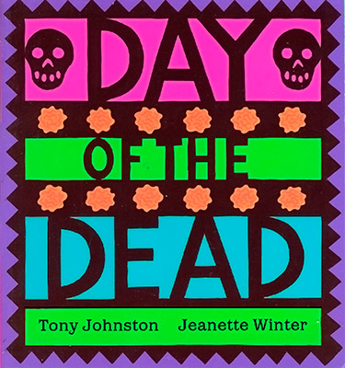
Introduction
You will be creating a book about the Day of the Dead.
Task
You need to have a chapter on Events, Food & Recipes, History, Music and Symbols for Day of the Dead. You will also make a cover page. Make sure your name is on the coverpage or it will not be printed. Drop each chapter to Ms. Beth for printing as you get them done. There are links to help you.

