Akhenaton
?-1354 BC
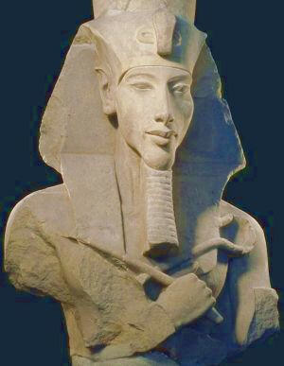
WHY HE MADE HISTORY Akhenaton was the Egyptian pharaoh who is known for encouraging Egypt to worship one god instead of many gods.

As you read the biography below, think about how
Akhenaton’s beliefs changed Egypt during his reign.

Akhenaton was pharaoh of Egypt during the eighteenth
dynasty. He first reigned under the name of Amenhotep IV,
inheriting the throne from his father when he was just
twelve years old. After six years as pharaoh, he changed his
name to Akhenaton to honor the sun god Aten. Akhenaton
is Egyptian for “Aton is satisfied.”

When Akhenaton’s reign began, Egypt was still practicing polytheism, or the worship of more than one god. Akhenaton believed in monotheism, the worship of just one god. The godhe worshiped was Aton, the sun god. Akhenaton believed that he was actually Aton’s son. He believed that Aton was all-powerful and absolute, so there could be no other gods. Akhenaton moved the capital of Egypt from Thebes. He built a new capital city, which he named Akhenaton, and dedicated it to his religion.

Akhenaton was married to Nefertiti, and the couple had six daughters. During this time, Egyptian artists represented Akhenaton and Nefertiti in an exaggerated style. Sculptures often showed the two with elongated heads and necks, and protruding stomachs. One of the most familiar images to come out of this dynasty is a bust of Nefertiti.
During his rule Akhenaton built many temples to honor the god Aton. Akhenaton was fanatical in his beliefs. He defaced every monument in Egypt where another god’s name appeared. This angered the people of Egypt and caused much resentment. Akhenaton was known as a cruel, but inept ruler. During his reign Egypt lost control of many of its provinces.

After his death in 1354 BC, Akhenaton’s mummy was destroyed and most of the references to him were removed from the temples and palaces throughout Egypt. The religion that Akhenaton founded became unpopular. Many of the temples that Akhenaton built to Aton were later torn down to provide building materials that were used by other pharaohs to make their own temples.

Akhenaton’s son-in-law Tutankhamen became the next pharaoh. Tutankhamen, known popularly as King Tut, soon rejected monotheism and Egypt returned to polytheism.

